7PAM2000 Applied Data Science 1

Assignment 1: Visualisation

**Student Name: SrINIVAS Vegisetti**

**Student ID: 21080840**

Contents

GitHub Repository Link 2

Plot 1 2

Graph to Produce the Line Plot, which is based on the numerous well-labeled, well-titled columns of the dataset. 2

Graph 2

Conclusion: 2

Plot 2 3

Graph to Produce the Bar Plot, which is based on the numerous well-labeled, well-titled columns of the dataset. 3

Graph: 3

Conclusion: 3

Plot 3 4

Graph to Produce the Pie Chartt, which is based on the numerous well-labeled, well-titled columns of the dataset. 4

Graph: 4

Conclusion: 4

Reference 5

# GitHub Repository Link

Link:

This

# Plot 1

## Graph to Produce the Line Plot, which is based on the numerous well-labeled, well-titled columns of the dataset.

## Graph

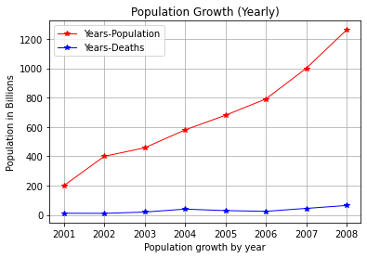

Figure 1

## Conclusion:

In above Figure 1, the Population growth and Death of the people is plotted in the graph. The type of graph that is used in figure 1 plotting is the Line Plot. The plotting is done in comparing multiple variables, the variable given in the dataset is “Population growth” and “Deaths of the People”. After plotting this graph, we can see the Population Growth and Deaths of the People to visualize which countries has the maximum growth and death.

# Plot 2

## Graph to Produce the Bar Plot, which is based on the numerous well-labeled, well-titled columns of the dataset.

## Graph:

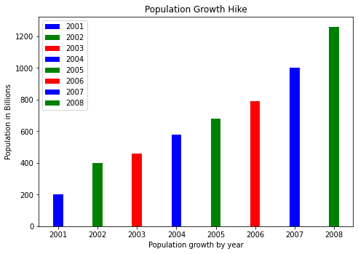

Figure 2

## Conclusion:

In the above Figure 2, The Bar graph is used for displaying the data. The Bar chart is convenient and showcases the population growth data to plot. In the above dataset, there are countries population varies yearly that is plotted in the graph. So, this plotting technique is more suitable for bar plotting the data which has numeric values in the columns.

# Plot 3

## Graph to Produce the Pie Chart, which is based on the numerous well-labeled, well-titled columns of the dataset.

## Graph:

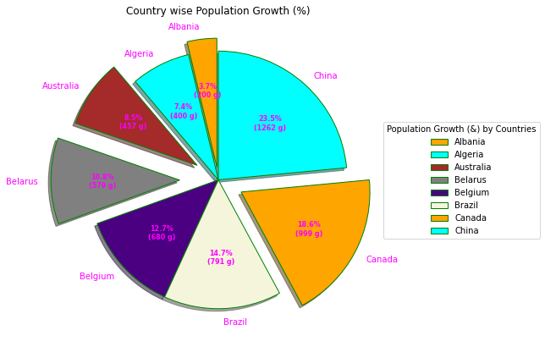

Figure 3

## Conclusion:

In the above graph, I use the Pie Chart to plot the data of the above dataset. The dataset has Countries and the Population Year wise growth. I select this graph because it plots both columns’ data in this graph and it is easy to understand for everyone because it differentiates all the data into the percentage format. This bar explains the percentage of the population growth of a country on the basis of the yearly hike of the population

# Reference

Line Plots:

<https://pythonbasics.org/matplotlib-line-chart/> and <https://pythonbasics.org/matplotlib-line-chart/>

Bar Plots:

<https://www.tutorialspoint.com/matplotlib/matplotlib_bar_plot.htm>

Pie Chart:

<https://www.tutorialspoint.com/matplotlib/matplotlib_bar_plot.htm>